Elements of Successful Data Findings Report

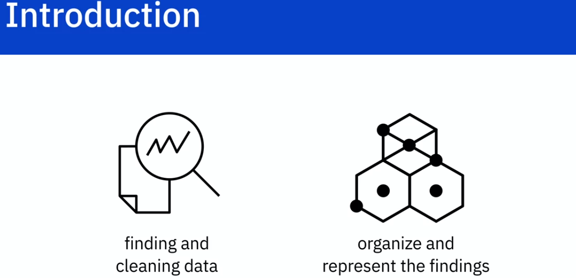

While finding and cleaning data is important , organizing it and presenting the finding to the audiance has greater importance.

Lets see how we can create a good report.

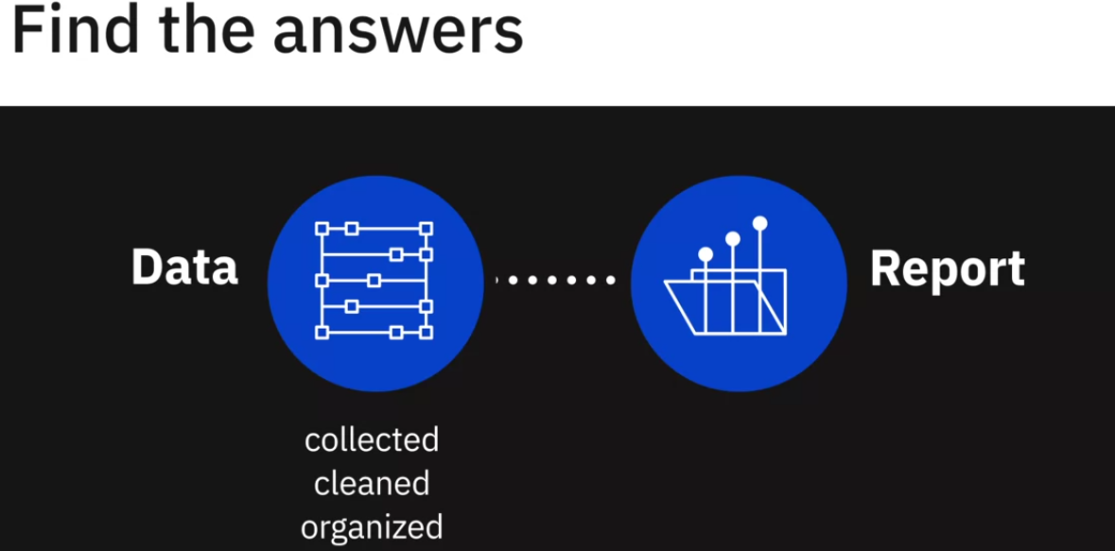

Once we have collected, cleaned and organized data. we hopefully can answer the question that was designed before starting the analysis.

We can use this understandings to file a report which can be in different formats.

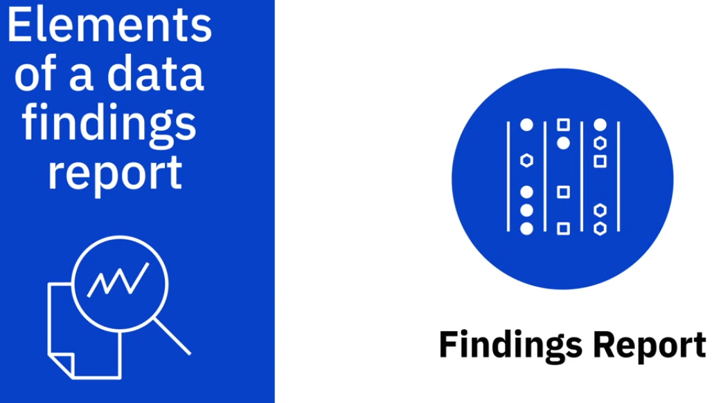

The findings report is crucial part of data analysis, as it conveys what was discovered. It might be overwhelming. The best way to get through this block is to begin by creating an outline.

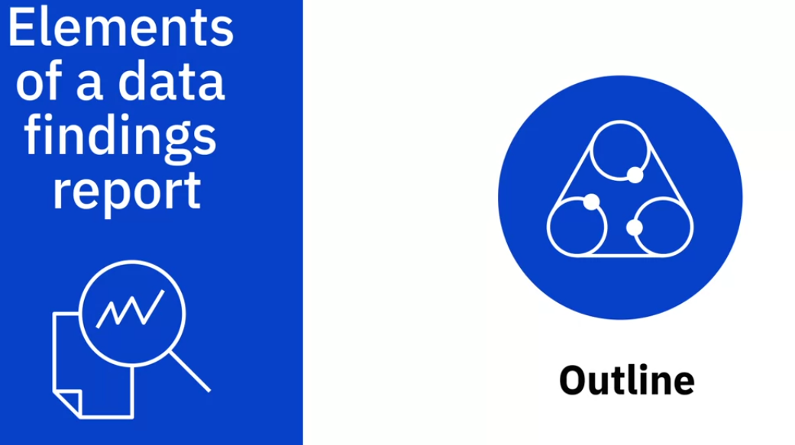

By completing an outline, we can then write a report in precise but simple manner.

Remember to create an focusing on the audience.

Create a presentation that is appropriate for your situation.

The following is the outline to follow.

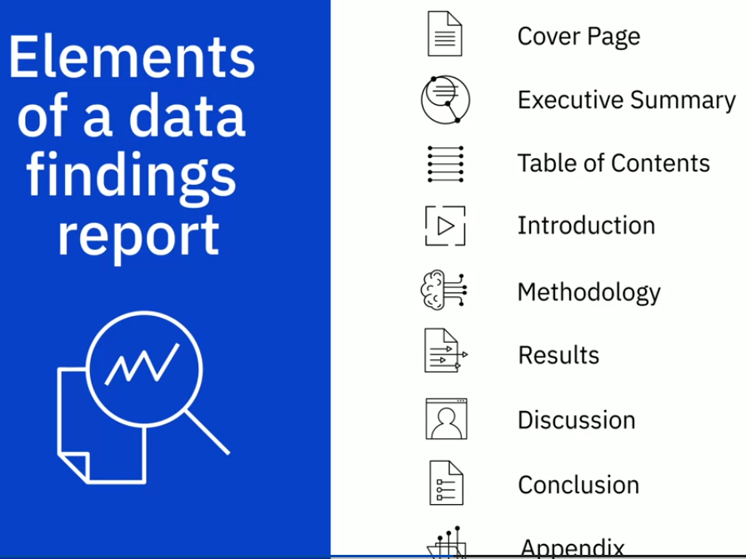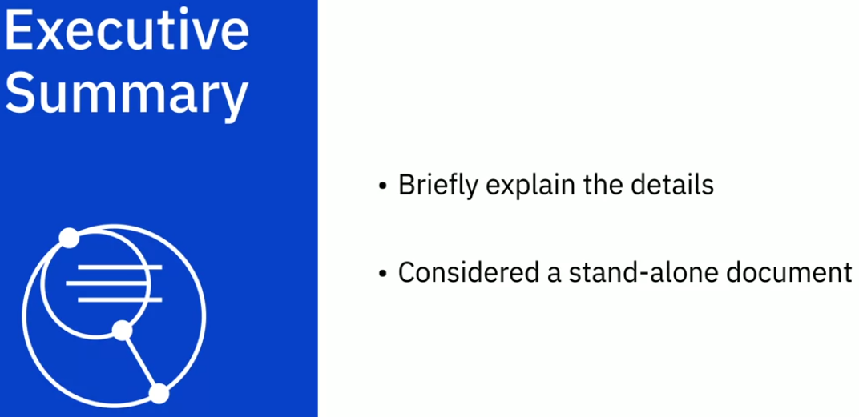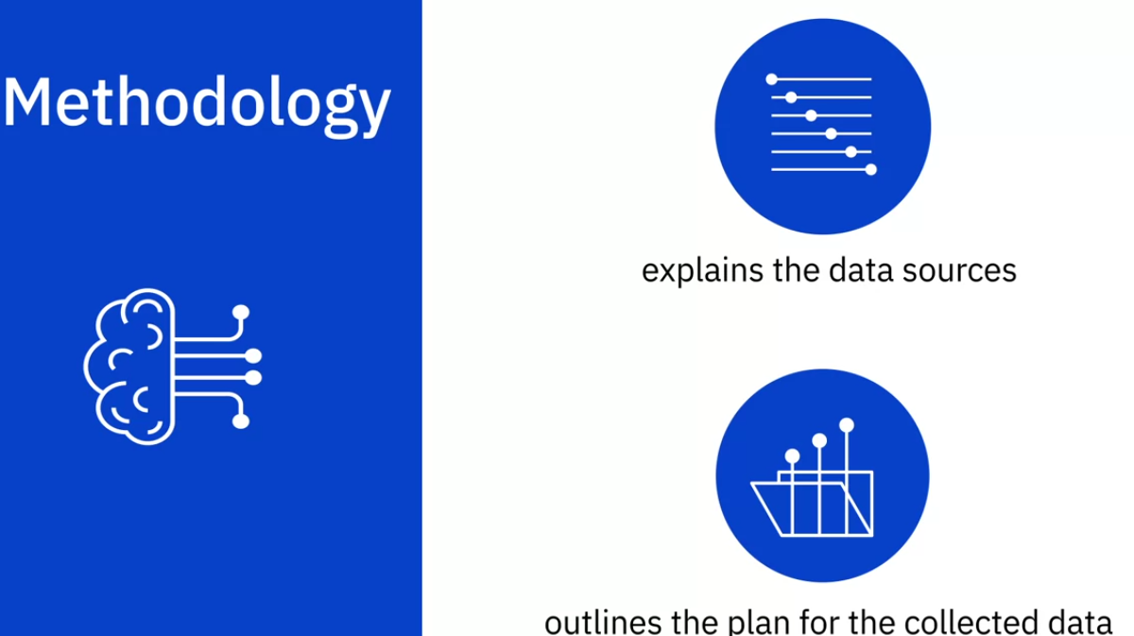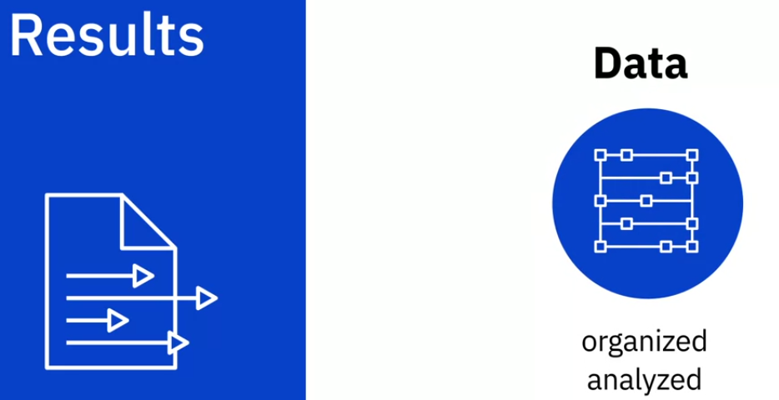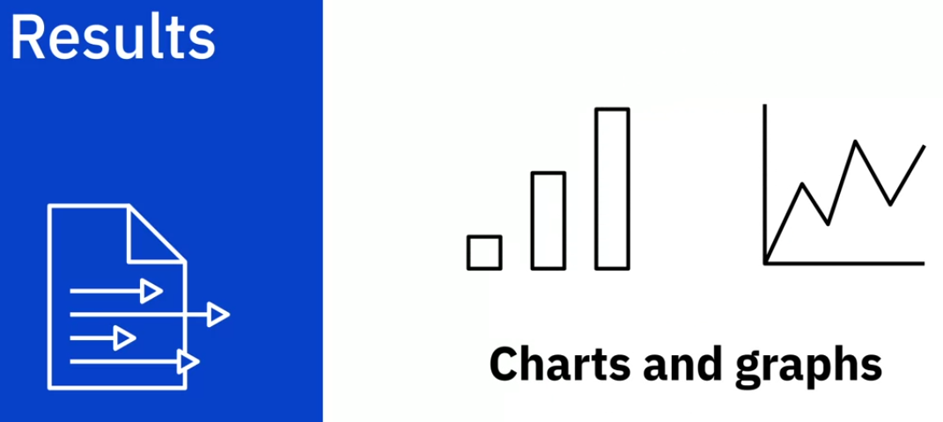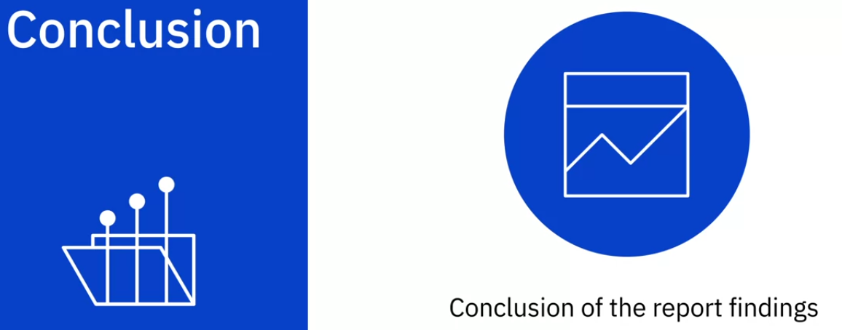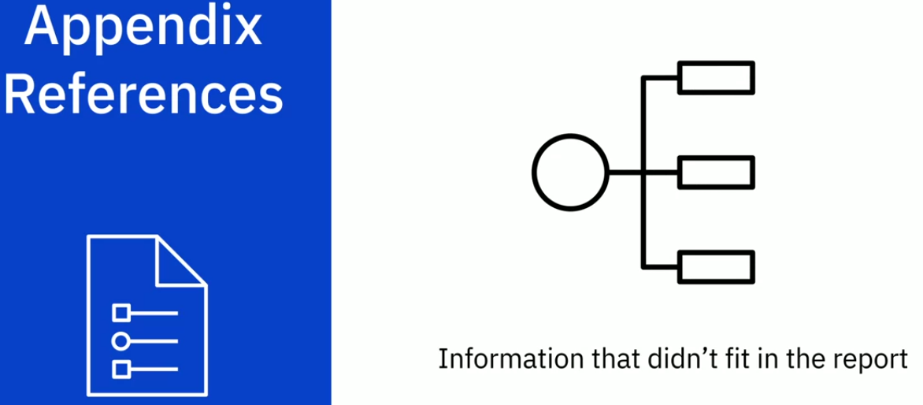

Best Practices for Presenting Your Findings

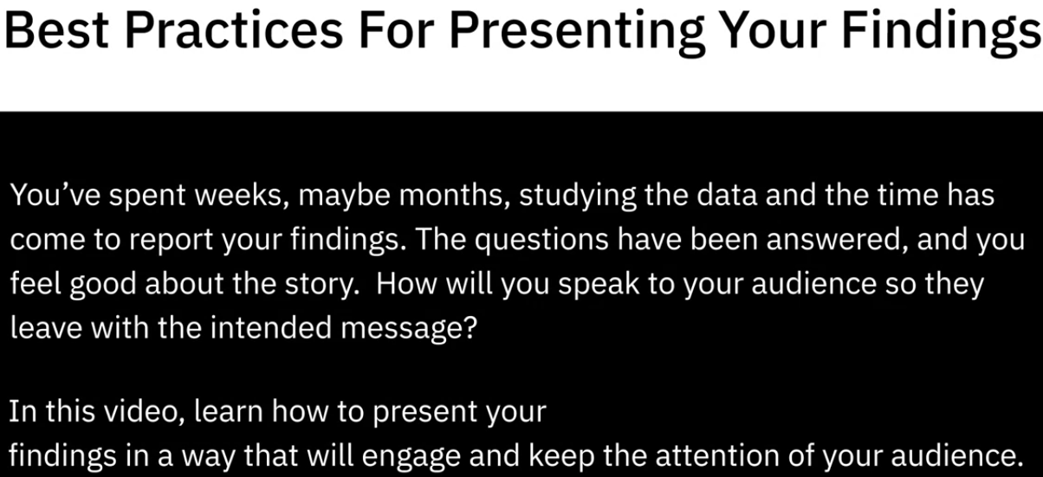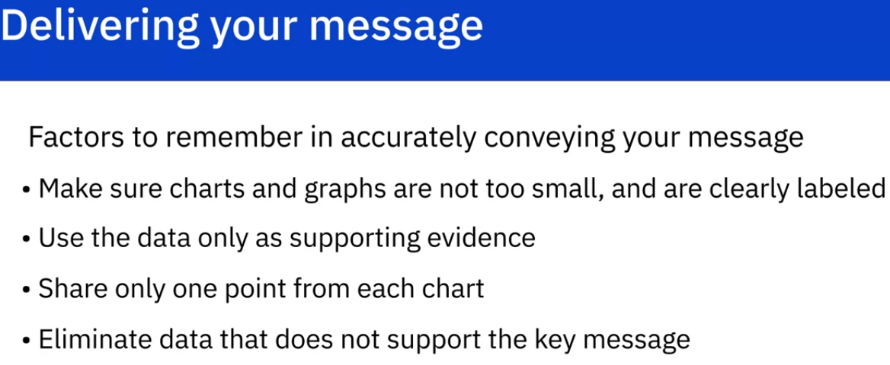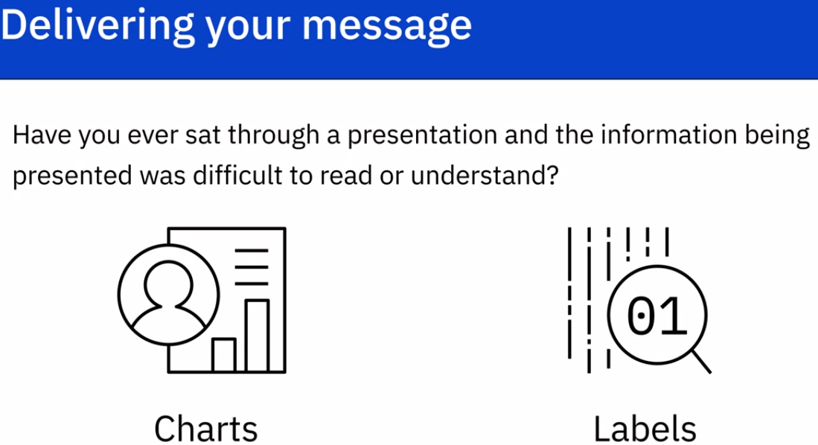

Small charts and labels can be easily dismissed. So test the charts and label sizes at differnt distances.

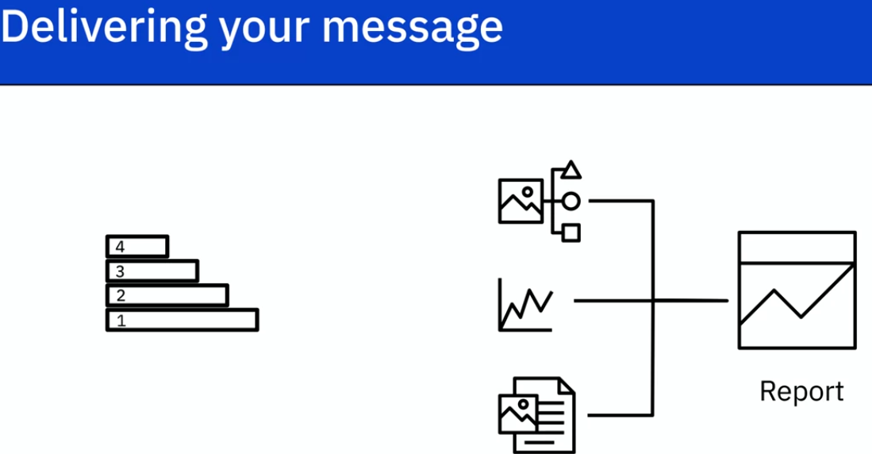

Do not pile the report with just data. Start creating a story to explain the data better. Make it more engaging and interesting to audience.

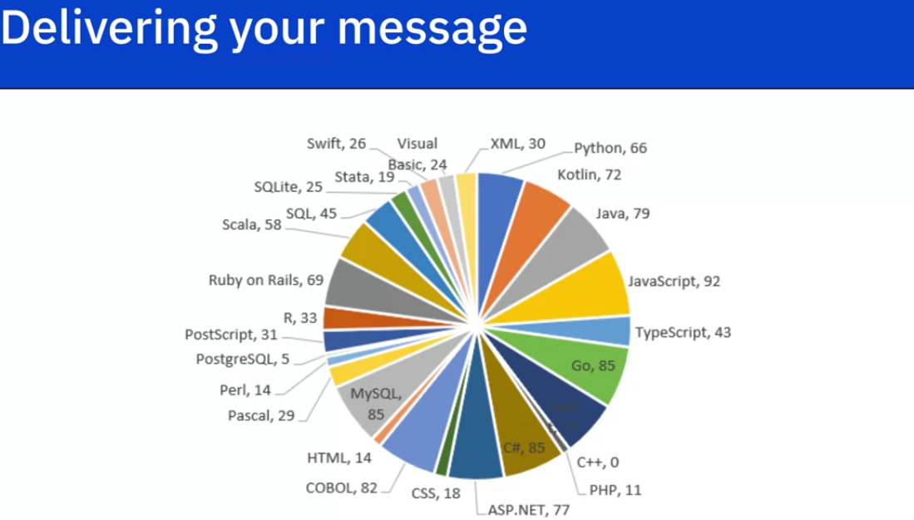

Do not provide charts with too much information.

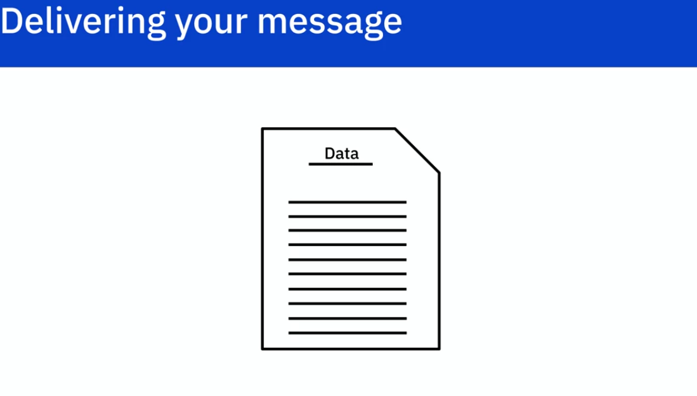

Things that might be interesting to Data Scientists might not be interesting to end user. Do not try to explain each and every single point. Recognize irrelevant data and elemenate it.

